Technology Stack Template
GARAGE MANAGEMENT SYSTEM

DATE | 3.11.2025
TEAM ID | NM2025TMID01428
PROJECT NAME | Garage Management system
MAXIMUM MARKS | 2 MARKS

Garage Management System
The Garage Management System is a valuable tool for automotive repair facilities, helping them deliver top-notch service, increase operational efficiency, and build lasting customer relationships. With its user-friendly interface and powerful features, GMS empowers garages to thrive in a competitive market while ensuring a seamless and satisfying experience for both customers and staff.

System Architecture
The system is a web-based application where customers can book services, track repair progress, and receive invoices. Admins can manage mechanics, spare parts, and customer data through a dashboard. Data is stored in a database, and the system runs on a cloud server for better scalability and performance.
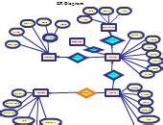

Flow Diagram
The following diagram represents the workflow of the Garage Management System:

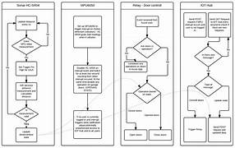

Architecture Diagram
The architecture of the Garage Management System is illustrated below:
